Monopoly Game

## Developers List

| **Name** | **Sections** | **ID** |
| --- | --- | --- |
| Thomas Khaled | 5 | 2017170004 |
| Ramez Nabil | 6 | 2017170149 |
| Abanoub Lotfy | 1 | 2017170003 |
| Abanoub Moris | 1 | 2017170004 |

**Description**

**❖ The rules are the same as the standard monopoly game:**

* The board consists of a few fields (cities, train stations, chances, etc).
* The game starts by all players having the same amount of money, waiting at the GO field.
* If the player buys all fields in the same colour, he can build a house on it and max houses is 4 then he can build a hotel.
* Each player gets a turn and buys properties by their listed prices.
* If a player arrives at another player's property, they must pay the rent which it is increasing for every building.
* If the player arrives at prison area or go to prison, he must wait two turns or pay 50$ and play his turn.
* If any player crosses the Go field after first turn the bank pay money for him for each full cycle.
* The game ends when one player remains the only one with money.

**❖ Basic Entities: fields, Groups, Properties (أملاك) ,Players:**

* ➢ Fields Details:
  + The board consists of a few fields.
  + Each Field has a fixed position on the board.
  + Fields can be properties (cities) or chances.
* ➢ Group Details:
  + Each group consists of two to three properties.
* ➢ Properties Details:
  + Each property has a listed price.
  + Each property belongs to a group.
* ➢ Players Details:
  + All players should start the game at the GO field.
  + Each player starts the game with the same amount of money.
  + Each player has a current position (on a field).
  + Each player has several properties which they bought.
  + When a player stops at another player's property, they should pay rent.
  + Each player can make a deal with any player in a specific city but should the player who make the trade arrives in the city where he needs to make deal on it.
  + Each player can accept the deal or refuse.

**❖ The interface should allow players to:**

* Decide the number of players.
* Decide the colour of each player.
* Choose whether to buy properties or not.
* Choose whether to pay rent or leave the game.

**Packages and Classes with Functions**

* **Buildings:**
* HBuildings.
* VBuidings.
* **GamePlay.img**
* It contains images for roll dice and the interface fields.
* **GamePlay.img.cards**
* It contains images for all cards.
* **GamePlay.soundEffects**
* It contains all sounds in the game.
* **GamePlay0**
* Cards.
* CardsDraw.
* ChanceCards.
* Community_Chest_Draw.
* Dice.
* DrawGamePlay.
* Gameplay.
* NewJFrame1.
* Player_pnl.
* SingletoneGamePlay.
* SoundEffects.
* Zone.
* Pic.
* trade_pnl.
* zoneEvents
* **NewGame**
* GameOver.
* StartScreen.
* **Playerpkg**
* DesitionPanel.
* JailOption.
* Player.
* PlayerCurrentPostion.
* SellOption.
* **SaveAndLoadGame**
* LoadGame.
* SaveGame.

**Flowchart**

**UML**

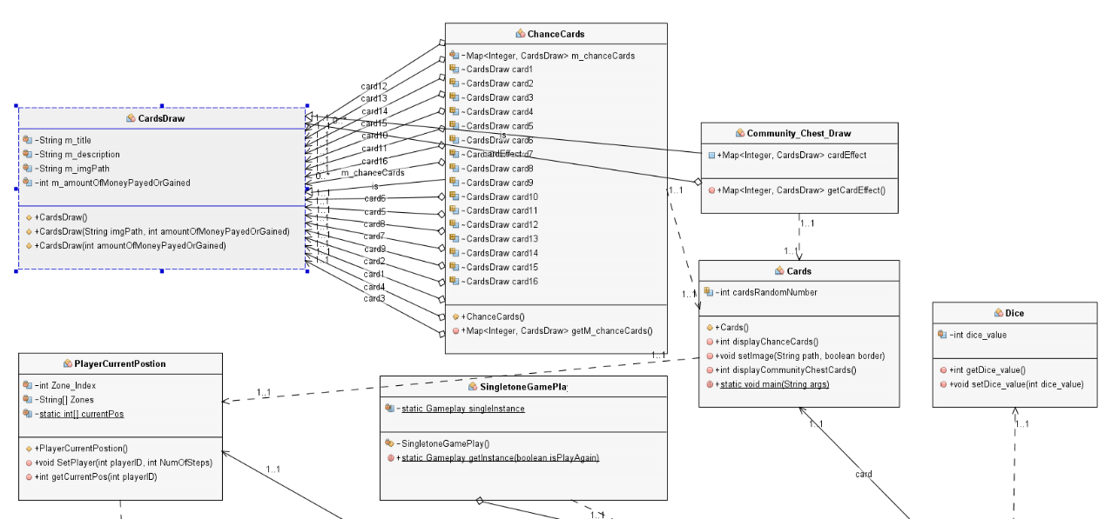

**UML cont.**

